Data Analysis

Roles Data

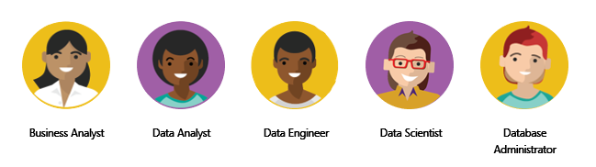

Scenario

Task of a data analyst